**10B.66**

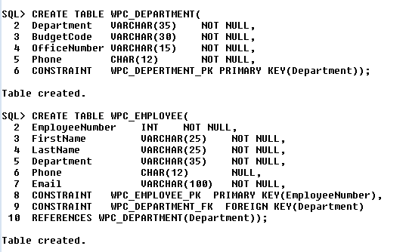

**10B.67**

INSERT INTO WPC_DEPARTMENT VALUES('Administration','BC-100-10','BLDG01-300','360-285-8100');

INSERT INTO WPC_DEPARTMENT VALUES('Legal','BC-200-10','BLDG01-200','360-285-8200');

INSERT INTO WPC_DEPARTMENT VALUES('Accounting','BC-300-10','BLDG01-100','360-285-8300');

INSERT INTO WPC_DEPARTMENT VALUES('Finance','BC-400-10','BLDG01-140','360-285-8400');

INSERT INTO WPC_DEPARTMENT VALUES('Human Resources','BC-500-10','BLDG01-180','360-285-8500');

INSERT INTO WPC_DEPARTMENT VALUES('Production','BC-600-10','BLDG02-100','360-287-8600');

INSERT INTO WPC_DEPARTMENT VALUES('Marketing','BC-700-10','BLDG02-200','360-287-8700');

INSERT INTO WPC_DEPARTMENT VALUES('InfoSystems','BC-800-10','BLDG02-270','360-287-8800');

INSERT INTO WPC_EMPLOYEE VALUES(

1,'Mary','Jacobs','Administration','360-285-8110','Mary.Jacobs@WPC.com');

INSERT INTO WPC_EMPLOYEE VALUES(

2,'Rosalie','Jackson','Administration','360-285-8120','Rosalie.Jackson@WPC.com');

INSERT INTO WPC_EMPLOYEE VALUES(

3,'Richard','Bandalone','Legal','360-285-8210','Richard.Bandalone@WPC.com');

INSERT INTO WPC_EMPLOYEE VALUES(

4,'Tom','Caruthers','Accounting','360-285-8310','Tom.Caruthers@WPC.com');

INSERT INTO WPC_EMPLOYEE VALUES(

5,'Heather','Jones','Accounting','360-285-8320','Heather.Jones@WPC.com');

INSERT INTO WPC_EMPLOYEE VALUES(

6,'Mary','Abernathy','Finance','360-285-8410','Mary.Abernathy@WPC.com');

INSERT INTO WPC_EMPLOYEE VALUES(

7,'George','Smith','Human Resources','360-285-8510','George.Smith@WPC.com');

INSERT INTO WPC_EMPLOYEE VALUES(

8,'Tom','Jackson','Production','360-287-8610','Tom.Jackson@WPC.com');

INSERT INTO WPC_EMPLOYEE VALUES(

9,'George','Jones','Production','360-287-8620','George.Jones@WPC.com');

INSERT INTO WPC_EMPLOYEE VALUES(

10,'Ken','Numoto','Marketing','360-287-8710','Ken.Numoto@WPC.com');

INSERT INTO WPC_EMPLOYEE VALUES(

11,'James','Nestor','InfoSystems',NULL,'James.Nestor@WPC.com');

INSERT INTO WPC_EMPLOYEE VALUES(

12,'Rick','Brown','InfoSystems','360-287-8820','Rick.Brown@WPC.com');

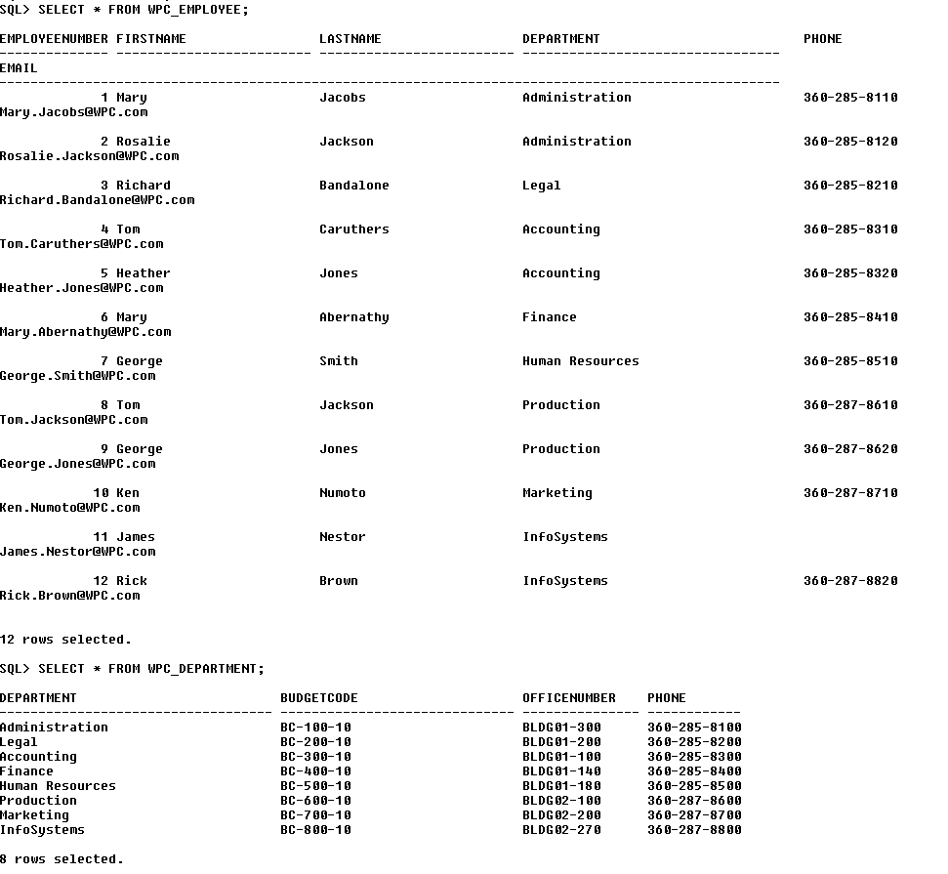

**10B.68**

CREATE OR REPLACE TRIGGER EMPLOYEE_BUR

BEFORE UPDATE ON EMPLOYEE

FOR EACH ROW

DECLARE

DEPT_EXCEPTION EXCEPTION;

PRAGMA EXCEPTION_INIT(DEPT_EXCEPTION, -20002);

L_COUNT NUMBER

BEGIN

SELECT COUNT(*) INTO L_COUNT FROM DEPARTMENT D

WHERE D.DEPARTMENT=:OLD.DEPARTMENT;

IF (:OLD.DEPARTMENT <> :NEW.DEPARTMENT) AND (L_COUNT > 0) THEN

RAISE DEPT_EXCEPTION;

END IF;

END;

**10B.69**

CREATE OR REPLACE TRIGGER DEPARTMENT_BDR

BEFORE DELETE ON DEPARTMENT

FOR EACH ROW

DECLARE

DEPT_COUNT_EXCEPTION EXCEPTION;

PRAGMA EXCEPTION_INIT(DEPT_COUNT_EXCEPTION, -20003);

L_COUNT NUMBER;

BEGIN

SELECT COUNT(*) INTO L_COUNT FROM EMPLOYEE E

WHERE E.DEPARTMENT=:OLD.DEPARTMENT;

IF (L_COUNT > 1 ) THEN

RAISE DEPT_COUNT_EXCEPTION;

END IF;

END;

CREATE OR REPLACE TRIGGER DEPARTMENT_ADR

AFTER DELETE ON DEPARTMENT

FOR EACH ROW

BEGIN

UPDATE EMPLOYEE

SET DEPARTMENT='HR'

WHERE EMPLOYEE=:OLD.EMPLOYEE;

END;

**10B.70**

CREATE OR REPLACE TRIGGER EMP_DEPT  
BEFORE  
INSERT OR  
UPDATE OF Department OR  
ON Employee  
BEGIN  
CASE  
WHEN INSERTING THEN  
DBMS_OUTPUT.PUT_LINE('Insert done');  
WHEN UPDATING('Department') THEN  
DBMS_OUTPUT.PUT_LINE('Updating Department');  
END CASE;  
END;

CREATE OR REPLACE TRIGGER  
BEFORE DELETE OF DEPARTMENT  
FOR EACH ROW  
BEGIN  
Delete DEPARTMENT INNER JOIN EMPLOYEE as emp where ((DEPARTMENT==emp.Department) AND COUNT(emp)>1;  
END;